**EXERCISE 1. SFTP to SFTP USING CPI**

**Table of Contents**

**Objective – SFTP to SFTP using CPI** 2

**Create end to end scenario.** 2

**Testing:** 14

**Revision History:**

|  |  |  |  |  |
| --- | --- | --- | --- | --- |
| **Version** | **Date** | **Author(s)** | **Reviewer** | **Revision Notes** |
| 1.0 | 15-Feb-2019 | Sidharth VR Sayantani Deb | Binod Kumar Mondal | First release of document |
|  |  |  |  |  |
|  |  |  |  |  |

# **Objective – SFTP to SFTP using CPI**

The Objective of this Interface is to pick a file from source and drop in the receiver folder.

# **Create end to end scenario.**

**Step 1:** Creation of Package

Please refer to the document attached.



\*\***NOTE**: “In case if the package is already created then skip this step and do not create package and directly go for “Integration Flow” creation.” **

**Step 2:** Creation of IFLOW

Click on the pencil icon (***Design***) and search for your Package ***‘Training_Demo_April_2019’*** and click on it to open it.

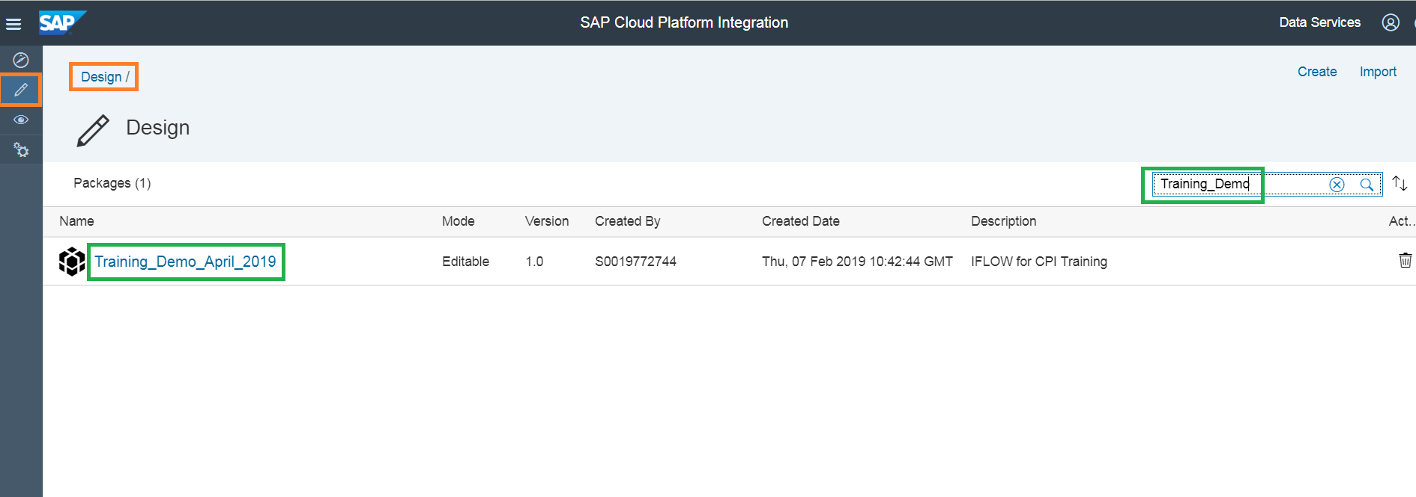

**Step 3:** Click on the ***‘Artifacts’*** tab highlighted in green.

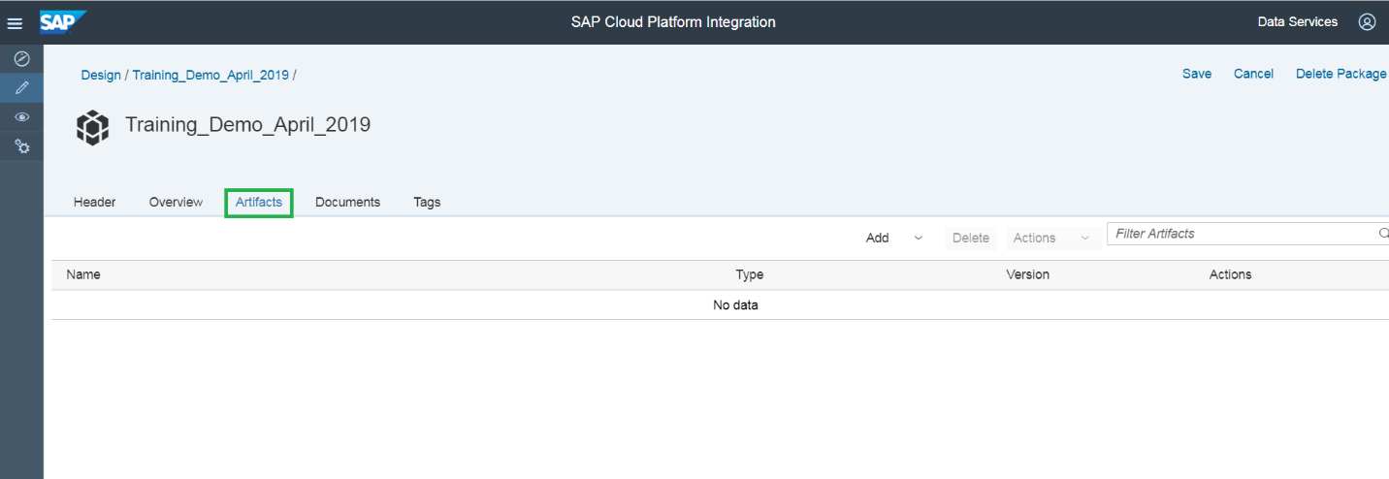

**Step 4:** Click on the ***‘Add’*** button and select the ***‘Integration Flow’*** from the drop down list to create an IFlow.

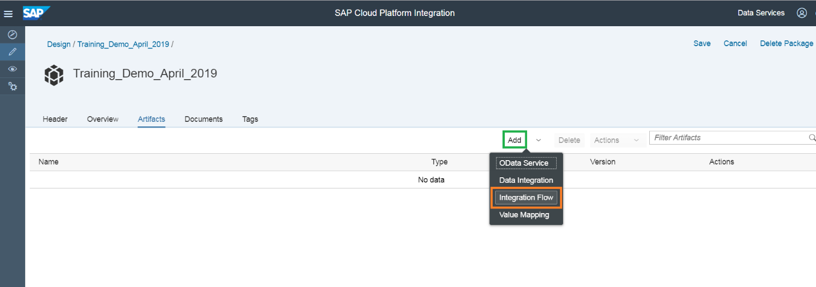

**Step 5:** Provide the details ***‘Name’*** and ***‘Description’***.

Name: ***File_to_File_Scenario_xxxx*** (Replace xxxx with your userid to maintain unique IFlows)

Description: ***IFlow for File to File Scenario*** (for example)

And click on ***‘OK’*** to create the IFLOW.

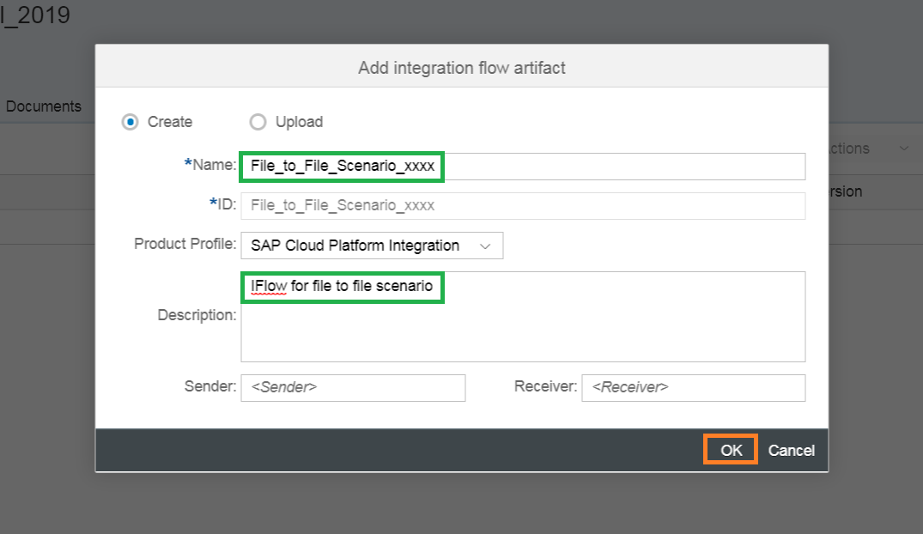

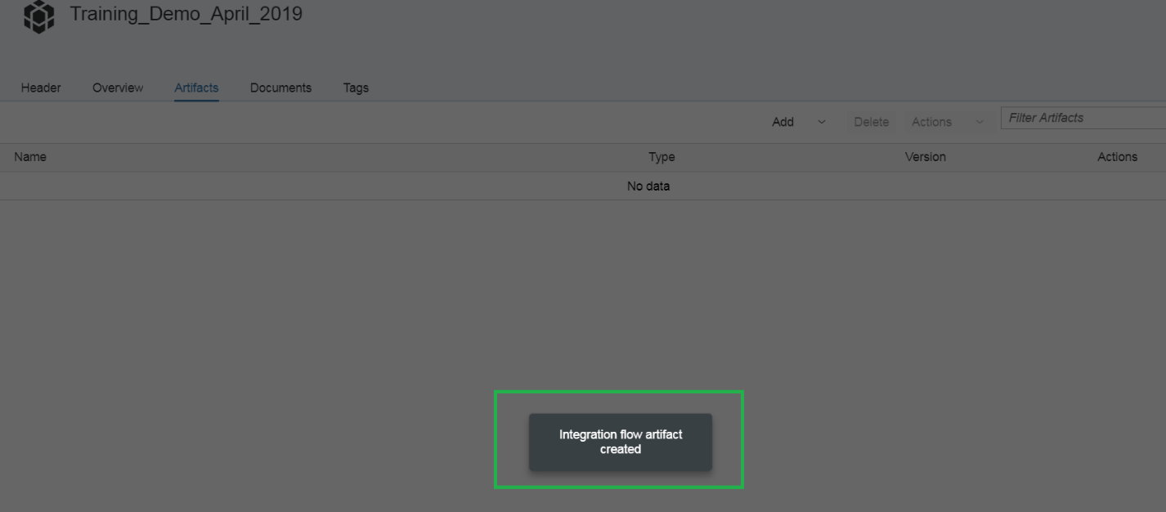

Your IFLOW is created.

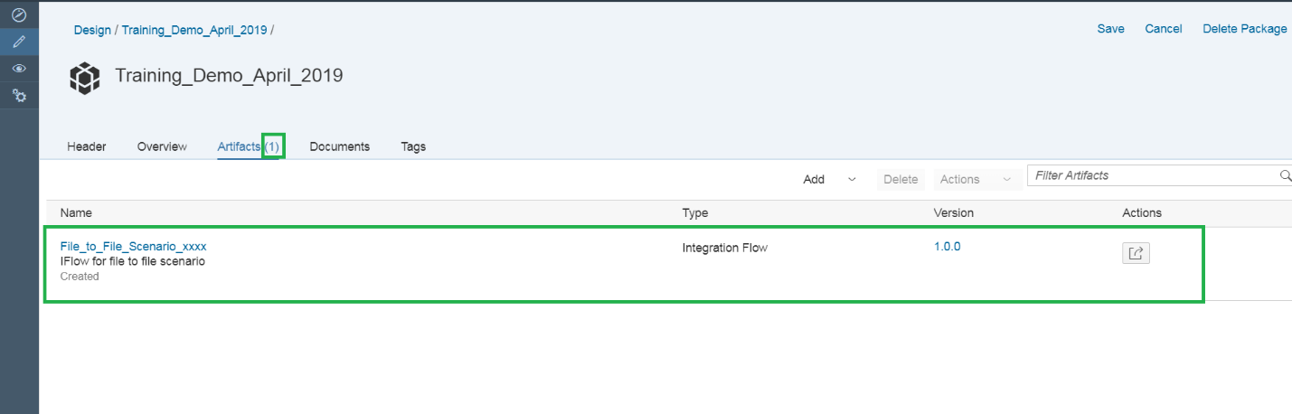

**Step 6:** Click on the IFlow created which is highlighted in green.

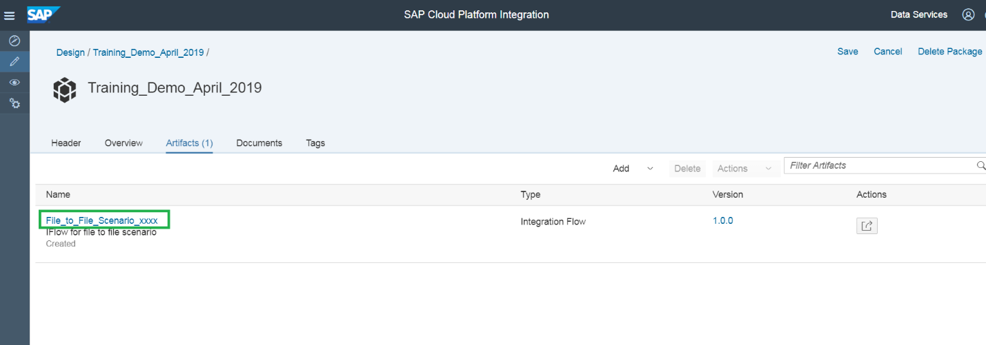

The IFLOW created:

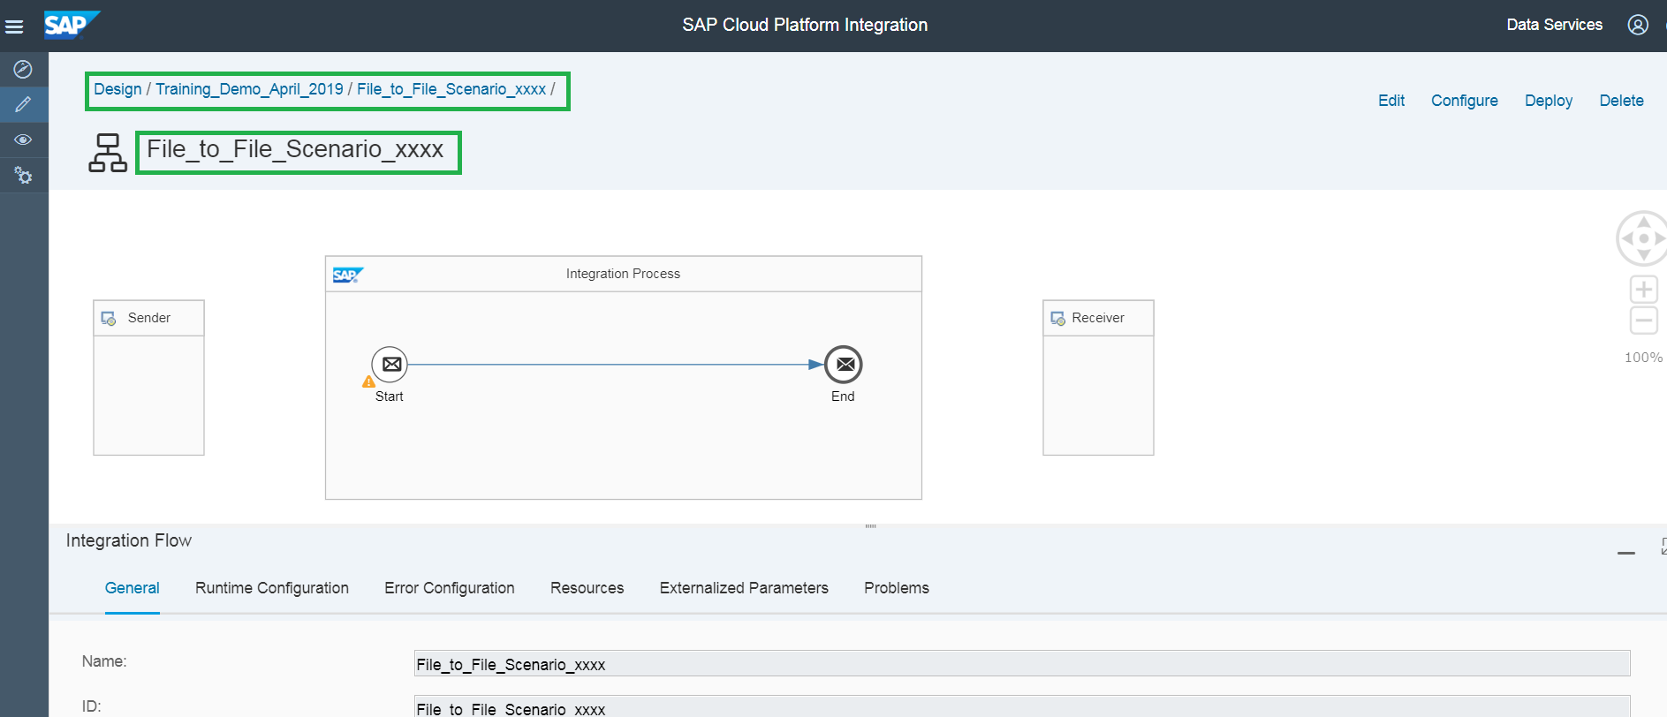

**Step 7:** Click on ***‘Edit’*** on the top right corner of the page to edit the IFLOW.

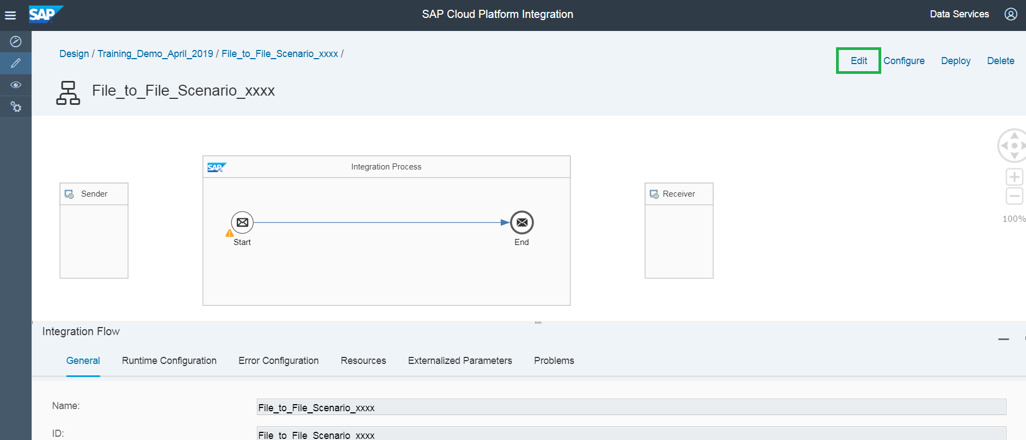

**Step 8:** Components of IFLOW required to create the File to File scenario

1. Sender
2. SFTP Sender Adapter
3. Content Modifier
4. SFTP Receiver Adapter
5. Receiver

**Step 9:** Sender and Receiver Systems

Click on ‘Edit’ and pick from the pallet on the left, the two participants🡪a Sender Participant and a Receiver Participant from the Pallet List.

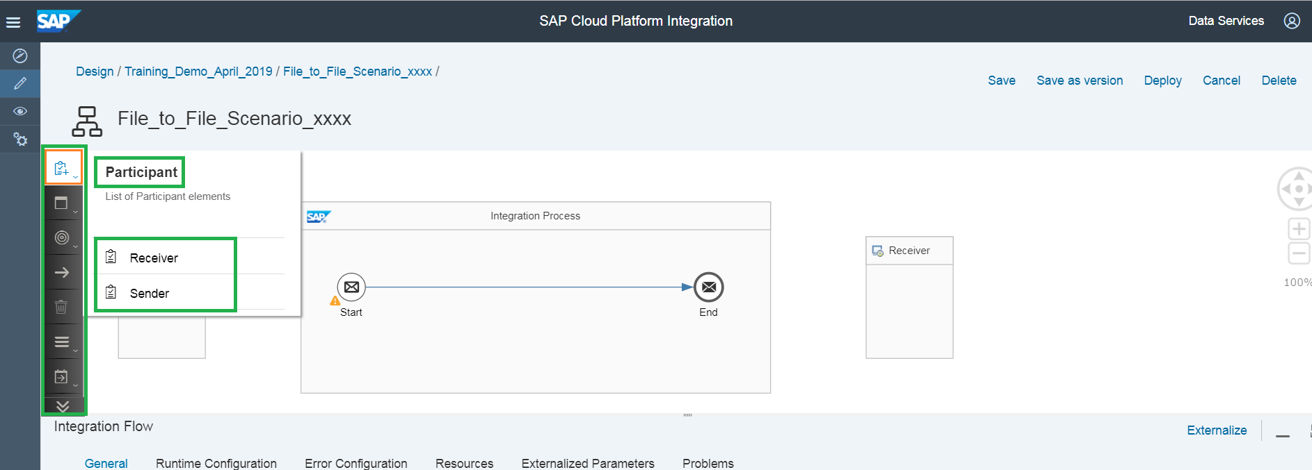

**Step 10:** Connect the Sender participant and Start message using SFTP Adapter.

Click on the Sender system on the left of the Integration Process box. You can see the arrow which is highlighted in green. Join arrow from the ***‘Sender system’*** to ***‘Start Message’*** (Circle with an envelope inside and named as ‘Start’).

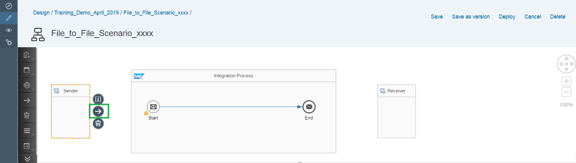

**Step 11:** Select the ***SFTP Adapter***.

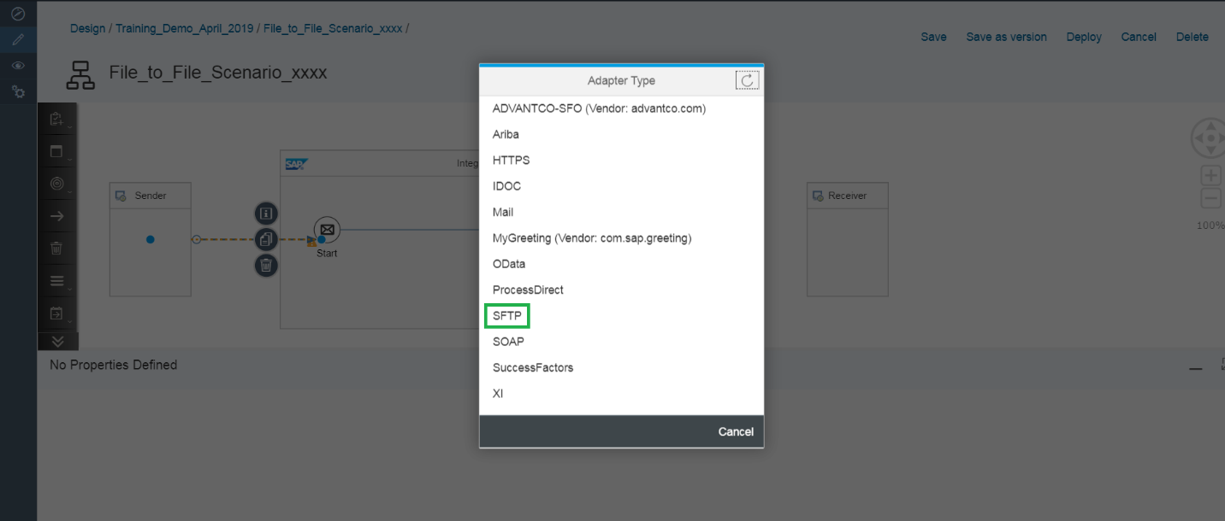

**Step 12:** Click on ***‘File’***. (Optional, if system pop up additional screen)

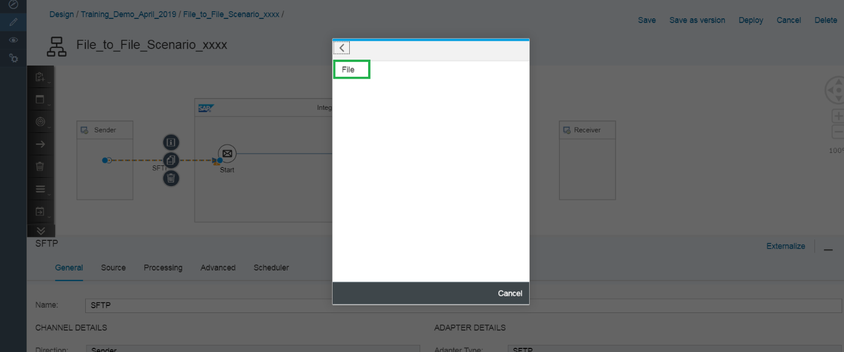

**Step 13:** Click on the sender dotted arrow connecting the Sender system and Start Message

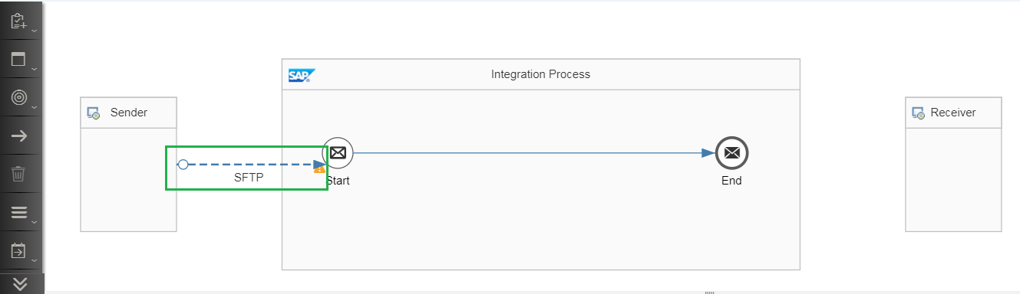

**Step 14:** Fill in the sender directory, filename, Address to SFTP server, Authentication and Credential Name. Select ***‘User Name/Password’*** from the drop list of ***‘Authentication’***.

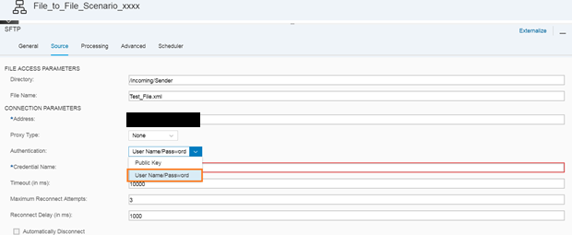

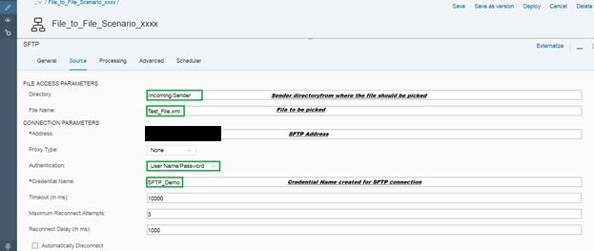

In our exercise use below:

Directory: ***/extuser/***

File Name: ***same filename from second scenario (for ex:1002_John.xml)***

Address: ***18.210.196.159***

Credential Name: Autocloud_SFTP

**Credential Name Creation**

**(Ignore steps 15, 16 and 17 for this demo since this is already registered in system)**

**Step 15:** Go to Monitor Tab>>Manage Security>>Security Material

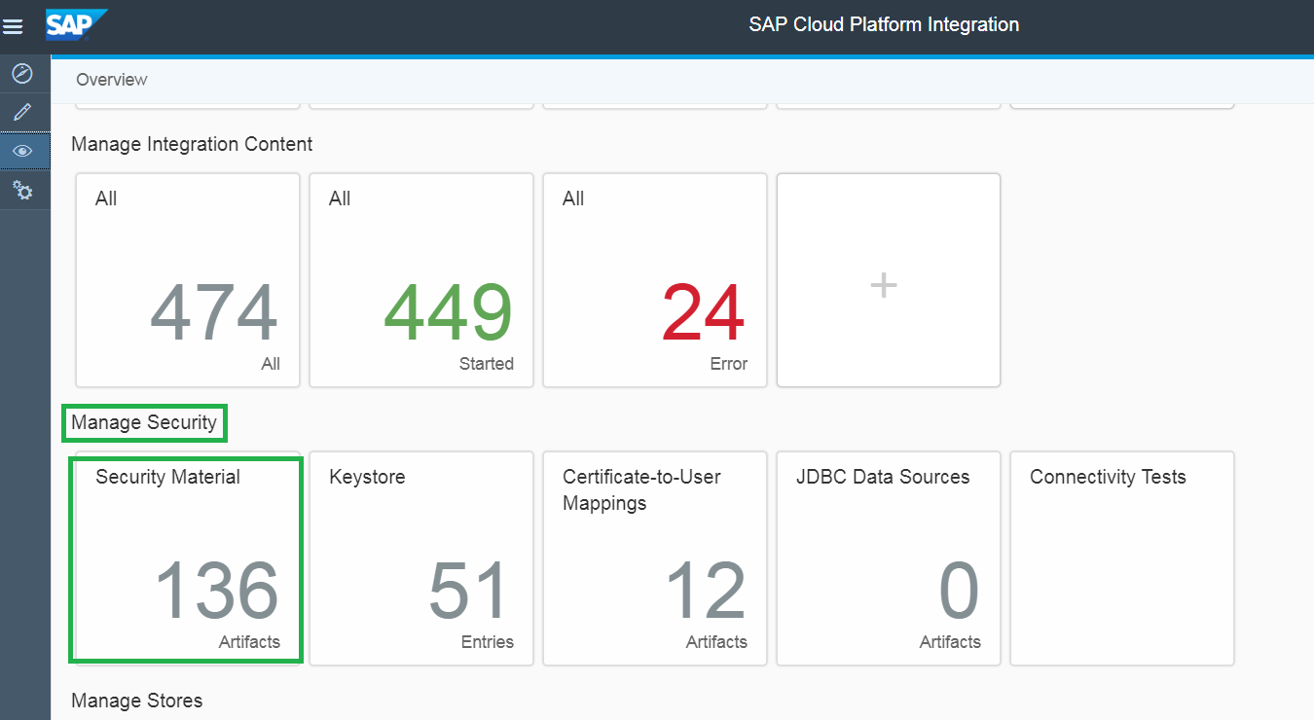

**Step 16:** Add a User Credentials to connect to SFTP server.

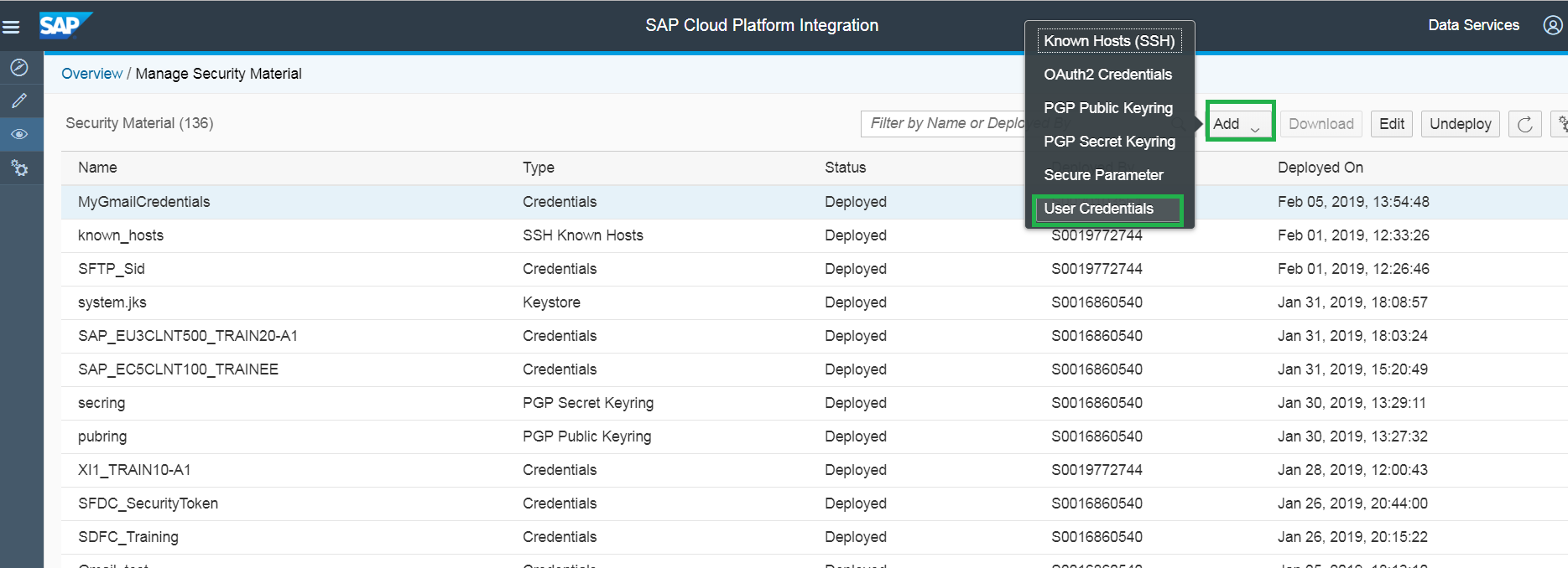

**Step 17:** Fill in the details and deploy the User Credential

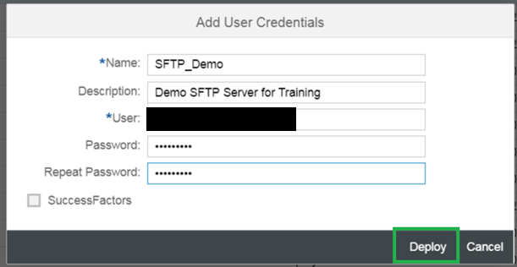

The Credential Name created:

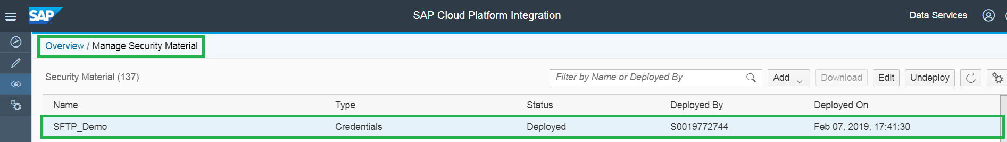

**Step 18:** Connection of End message to Receiver system

Similarly, Connect the End Message and Receiver SFTP Adapter.

Join arrow from the End Message to Receiver system and select the SFTP Adapter

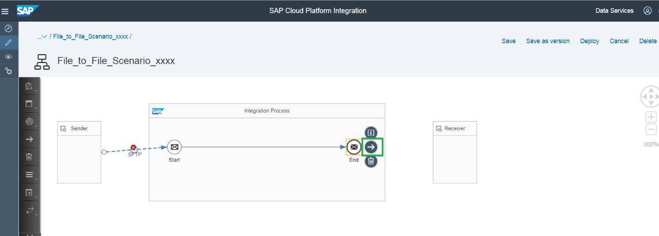

**Step 19:** Select ***‘SFTP’***.

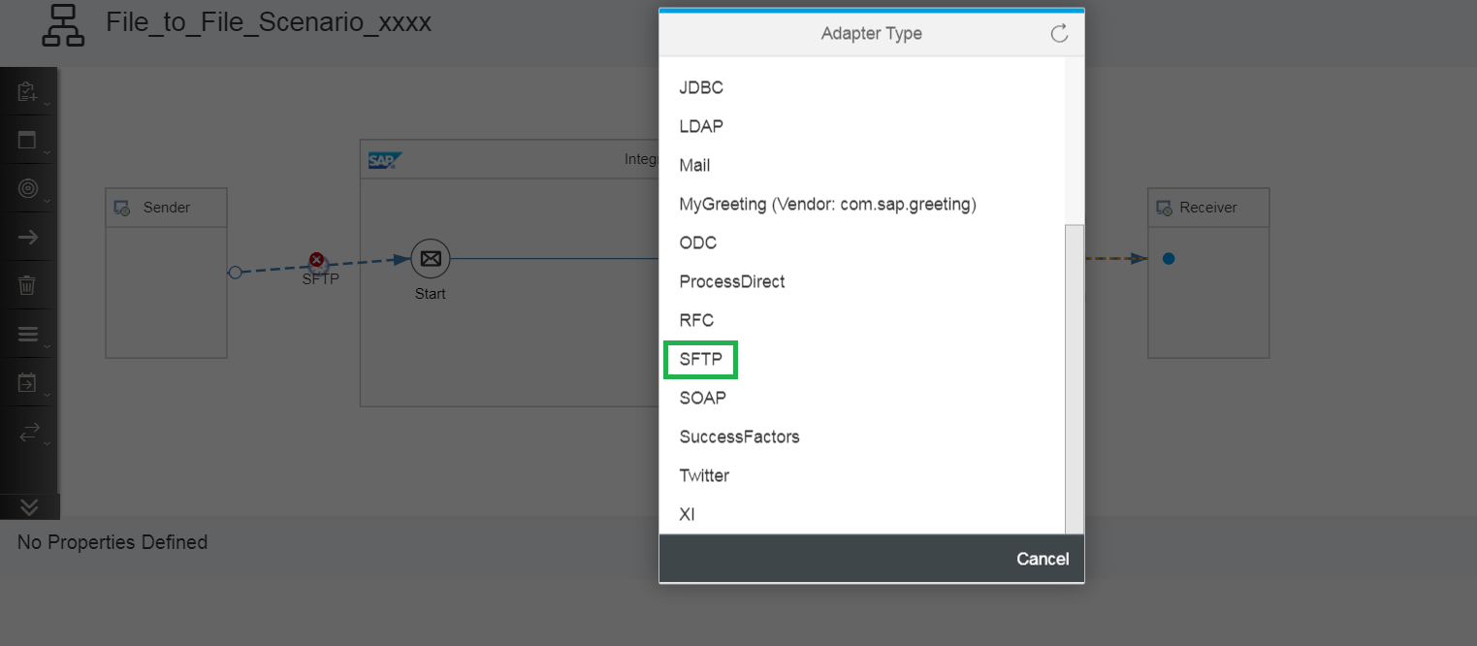

**Step 20:** Select ***‘File’***. (Optional, if system pop up additional screen)

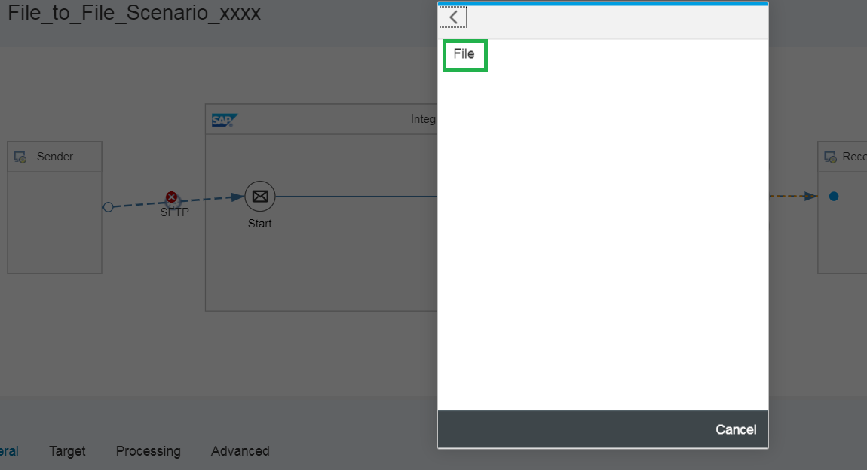

**Step 21:** Click on the dotted arrow connecting the End Message and Receiver system

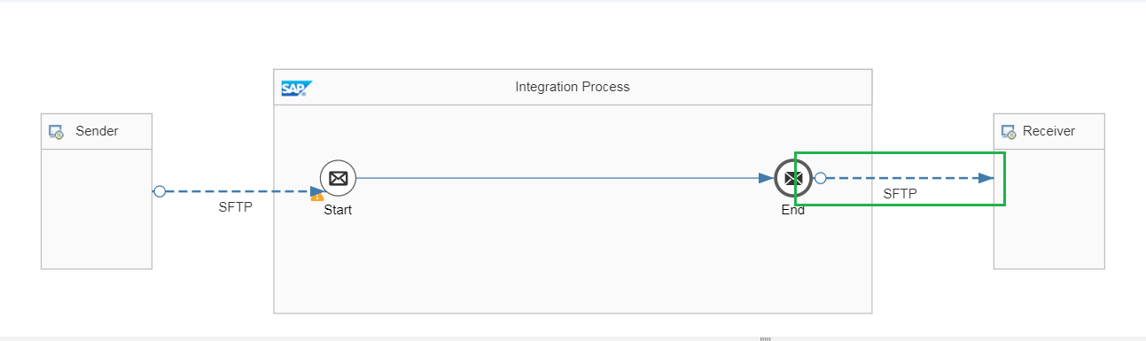

**Step 22:** Fill in the receiver directory, filename, Address to SFTP server, Authentication and Credential Name.

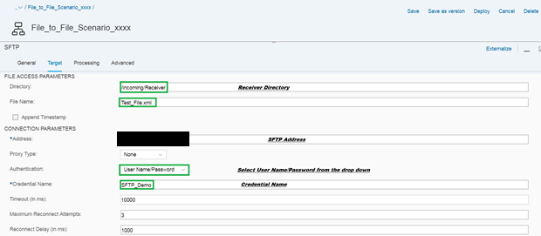

Directory: ***/extuser/***

File Name: ***${file:onlyname}***

Address: ***18.210.196.159***

Credential Name: Autocloud_SFTP

**Step 23:** Pick the Content Modifier from the Pallet under ***‘Transformation’*** and place the ***‘Content Modifier’*** between Start message and End message.

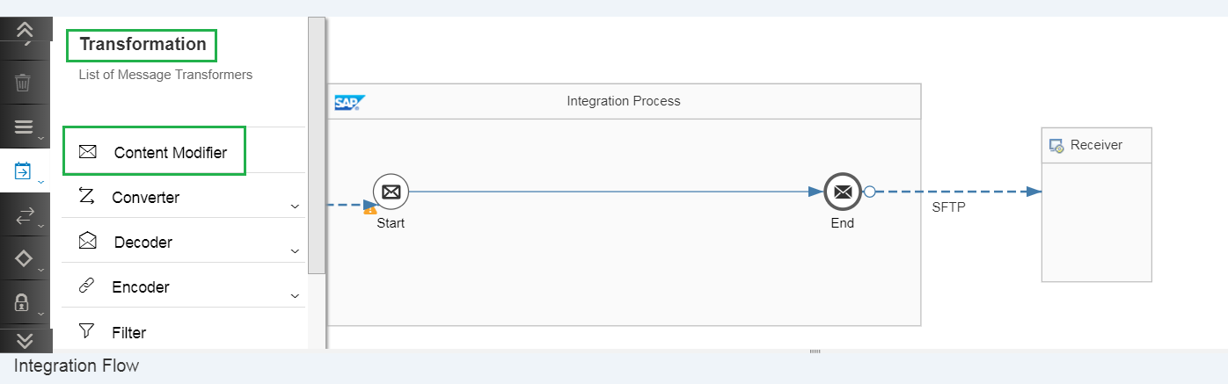

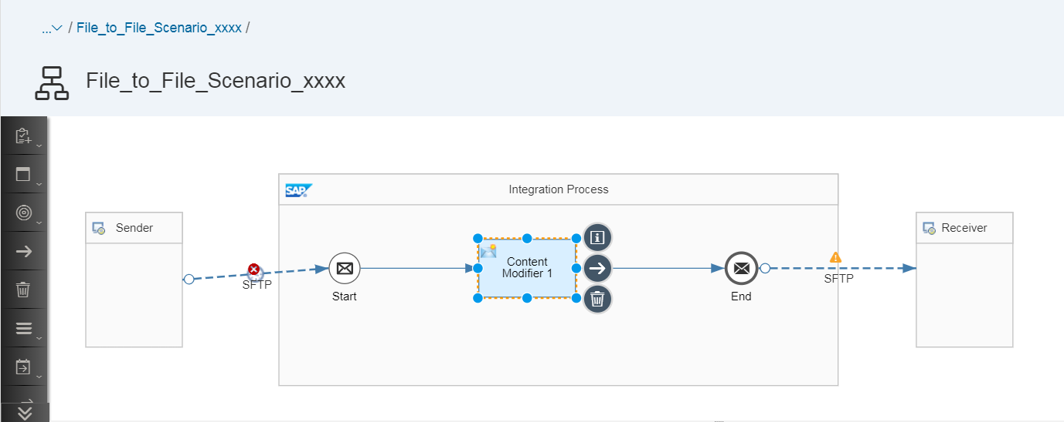

**Step 24:** Click on the ‘Content Modifier 1’ Box and click on the ***‘Add’*** button as highlighted below.

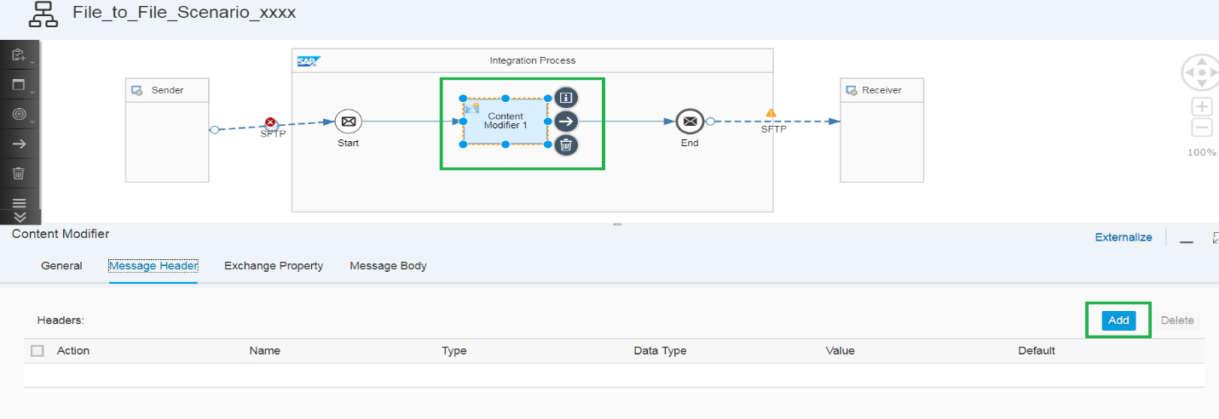

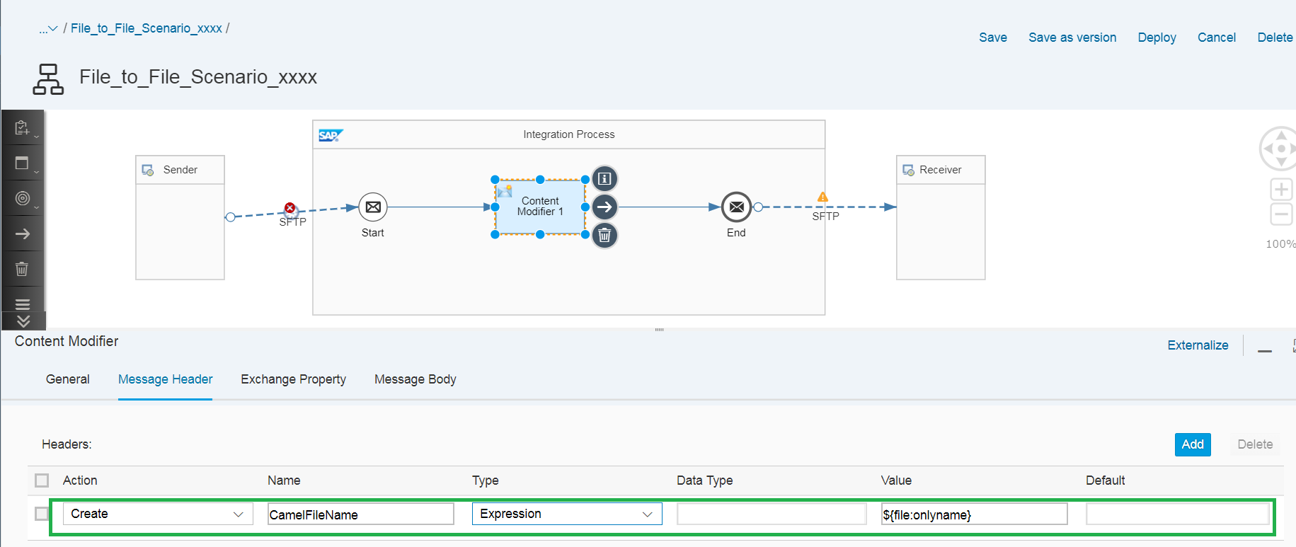

**Content Modifier** is used to modify a message by adding additional data to it. With Message Headers, we can add headers to it, edit and delete them.

Name: ***CamelFileName***

Type: ***Expression*** (From Drop-Down list)

Value: ***${file:onlyname}***

***(This will keep the same file name for receiver, If you want to customize the file name then try below)***

[***http://camel.apache.org/simple.html***](http://camel.apache.org/simple.html)

**Step 25:** Click on ***‘Save’***.

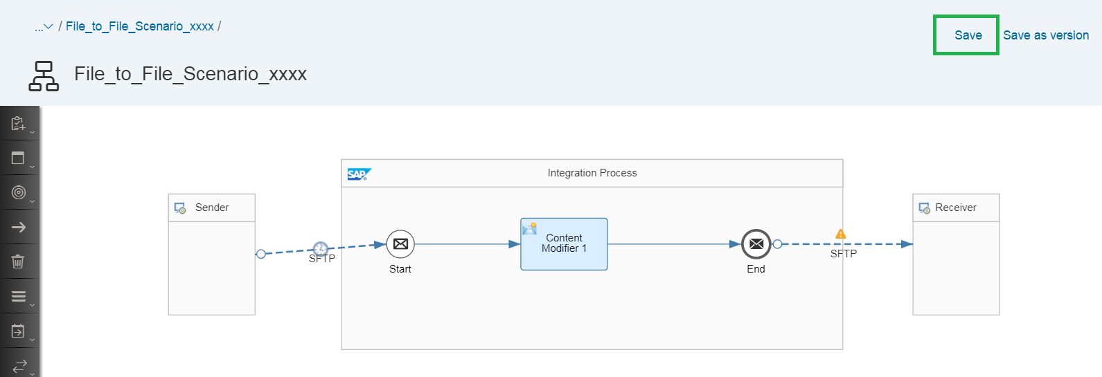

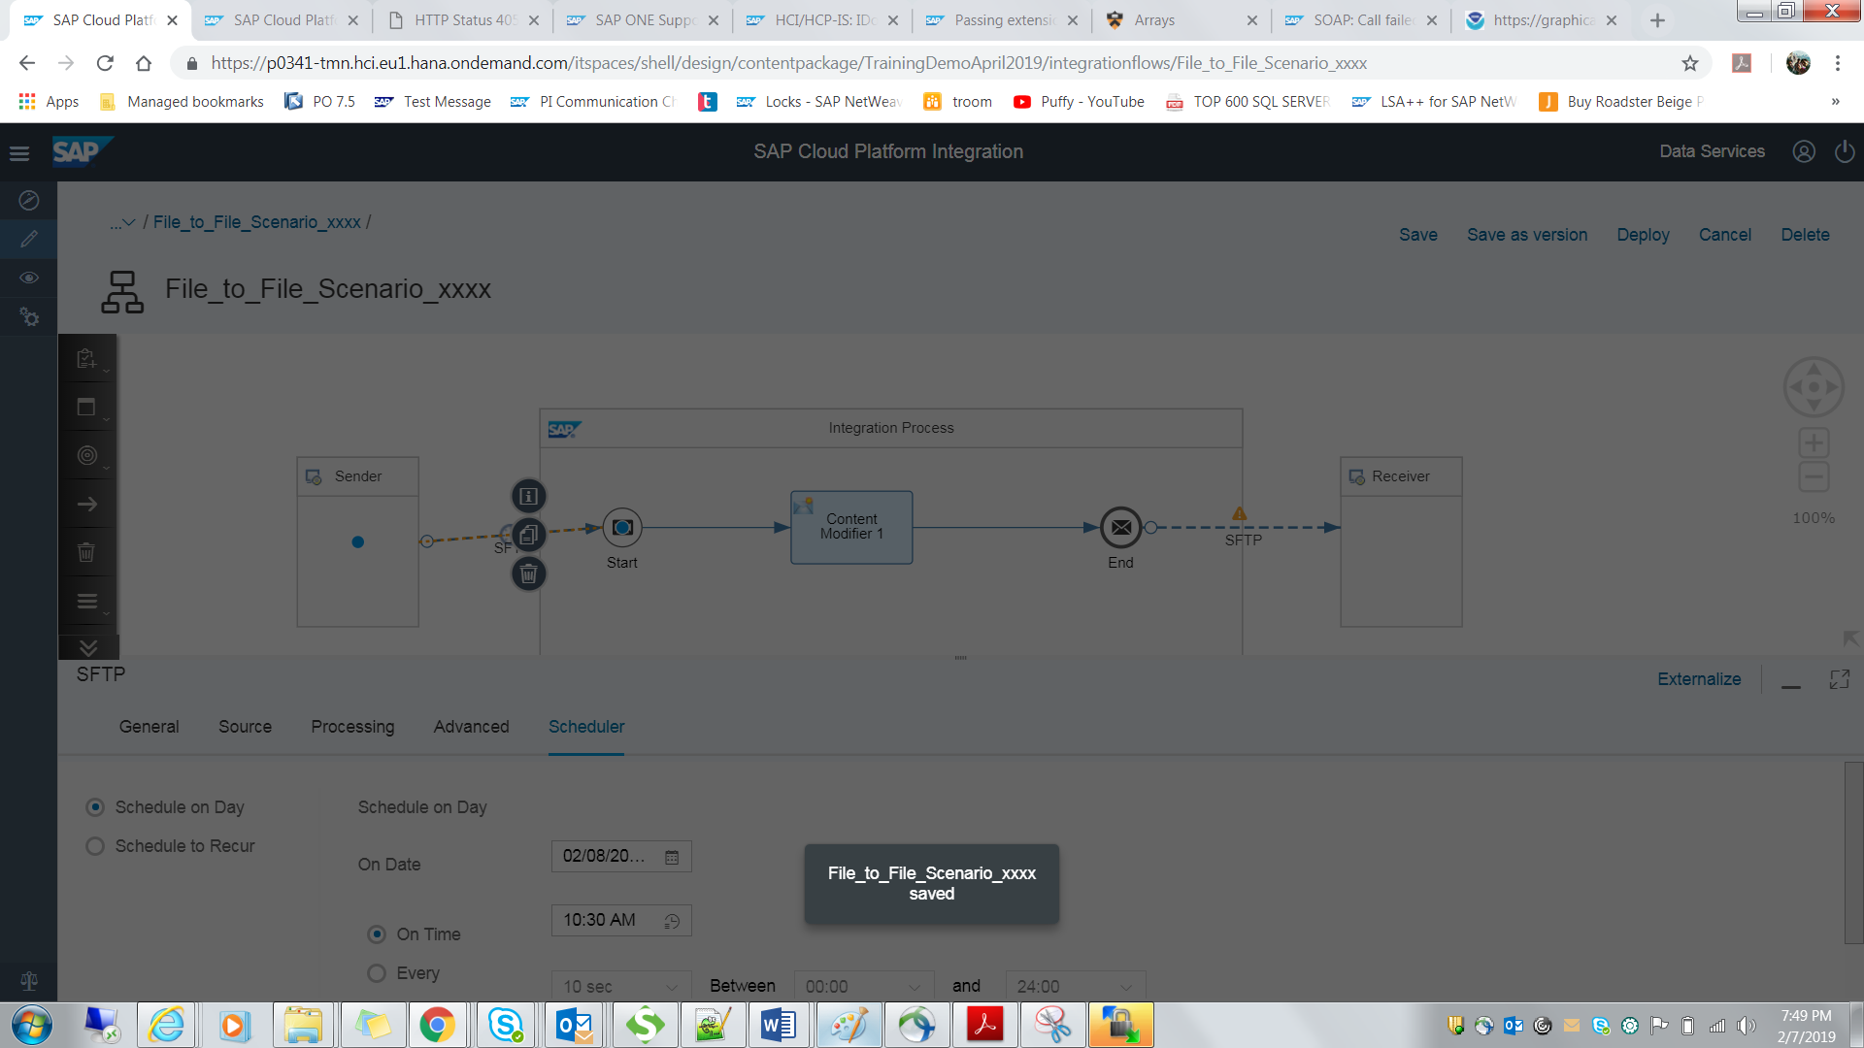

**Step 26:** Click on ***‘Deploy’*** to deploy the IFLOW.

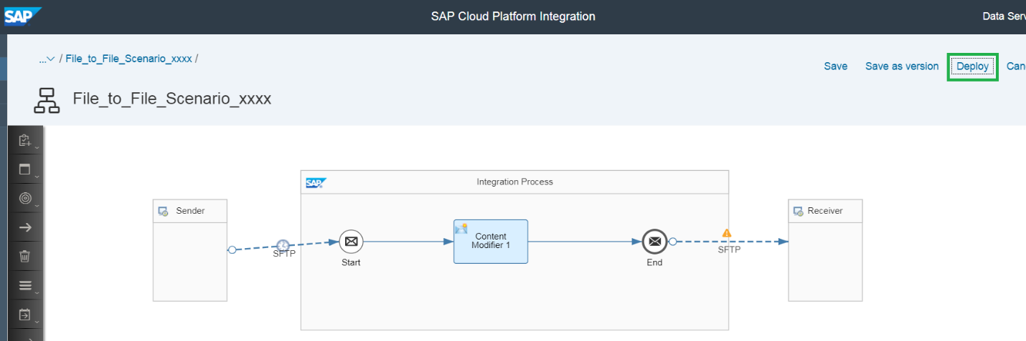

**Step 27:** Click on ***‘Yes’***.

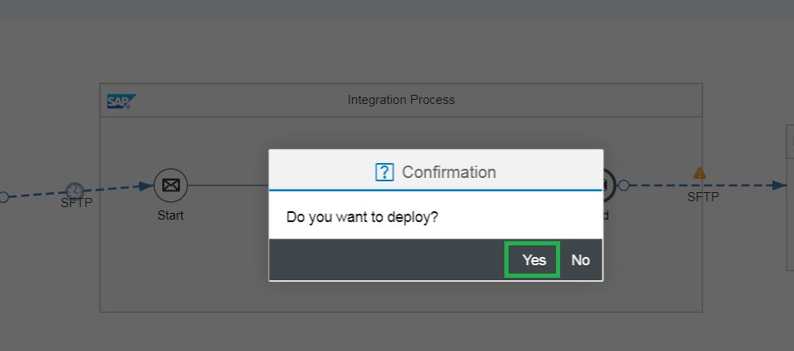

**Step 28:** Click on ***‘OK’***.

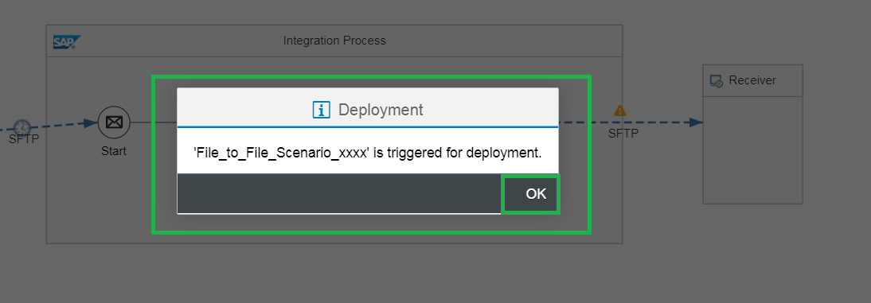

**It has been triggered for tomorrow’s date. The IFLOW will deploy on the next date.

# **Testing:**

Step 41: Trigger the second scenario and note down the filename in it.

That same filename should be in your sender SFTP channel

Processing parameter should be like this:

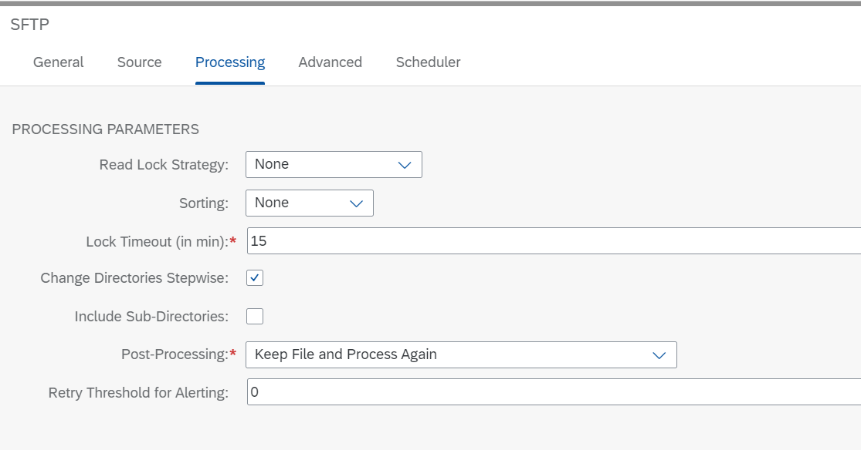

**Step 42:** Go to the sender SFTP Adapter (Step 13). Go to ***‘Scheduler’*** tab and select the ***‘Schedule on Day’*** radio-button. Give **today’s date**. Give 5-10 minutes later **time** in the ***‘On Time’*** field (because it takes a bit of time for the IFLOW to deploy and start and activate).

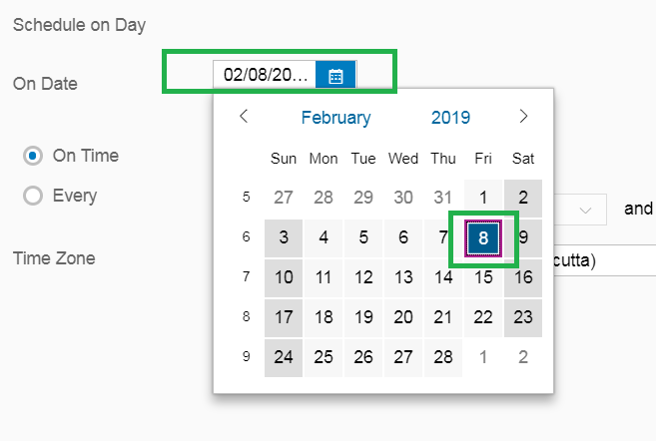

Current Time:



Select time 5-10mins later the current time.

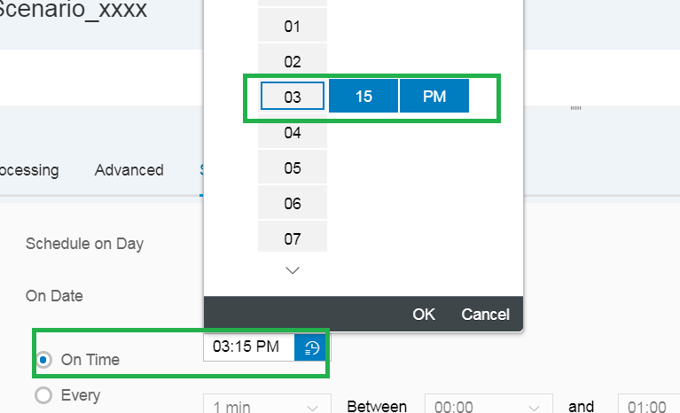

Also, select **Asia, Kolkata Time Zone** from the drop down list of ***‘Time Zone’***.

